**A picture containing clipart

Description generated with very high confidence**

PUPPET INSTALLATION

DevOps Certification Training

[**support@intellipaat.com**](mailto:support@intellipaat.com)

**+91-7022374614**

**US: 1-800-216-8930(Toll Free)**

**PUPPET INSTALLATION ON UBUNTU**

**Installing Puppet Master**

**Step 1:** Run the following commands for installing Puppet Master

$ sudo apt-get update

$ sudo apt-get install wget

$ wget https://apt.puppetlabs.com/puppet-release-bionic.deb

$ sudo dpkg -i puppet-release-bionic.deb

$ sudo apt-get update

$ apt policy puppet master

$ sudo apt-get install puppet-master

**Installing Puppet Agent**

**Step 2:**  Run the following commands for installing Puppet Agent

$ sudo apt-get update

$ sudo apt-get install wget

$ wget https://apt.puppetlabs.com/puppet-release-bionic.deb

$ sudo dpkg -i puppet-release-bionic.deb

$ sudo apt-get update

$ apt policy puppet master

$ sudo apt-get install puppet

**Configuring Puppet Master**

**Step 1:** Add the following lines in the puppet-master configuration file

$ sudo nano /etc/default/puppet-master

JAVA_ARGS="-Xms512m Xmx512m" **//Add this Line**

$ sudo systemctl restart puppet-master

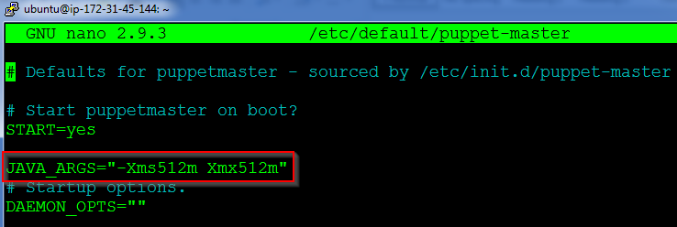

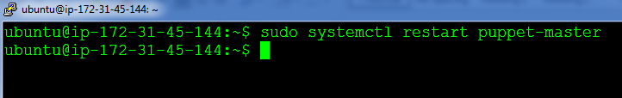

**Step 2:** Next open port 8140 on the Puppet Master’s firewall

$ sudo ufw allow 8140/tcp

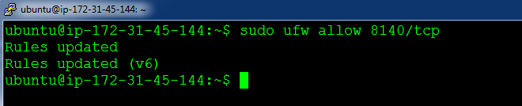

**Step 3:** Make changes to the hosts file which exists in /etc/hosts. And add the Puppet Master IP address along with the name “puppet”

$ sudo nano /etc/hosts

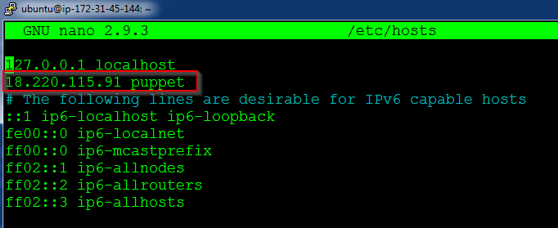

**Step 4:** Create the following directory path:

$ sudo mkdir -p /etc/puppet/code/environments/production/manifests

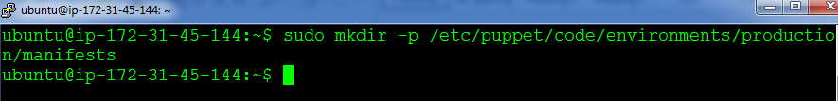

**Configuring Puppet Slave**

**Step 1:** Add the entry for Puppet Master in /etc/hosts

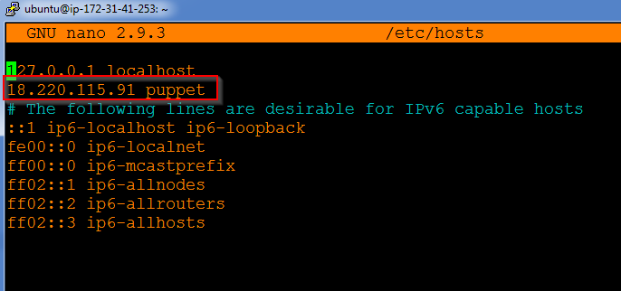

**Step 2:** Finally start the Puppet agent by using the following command. Also, enable the service, so that it starts when the computer starts

$ sudo systemctl start puppet

$ sudo systemctl enable puppet

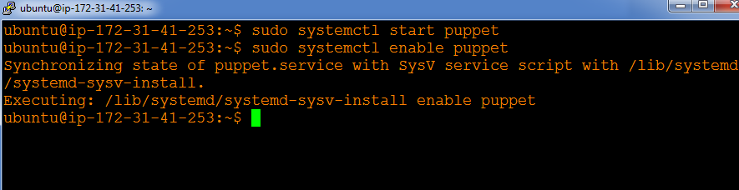

**On Master**

**Step 1:** Type the following command,

$ sudo puppet cert list

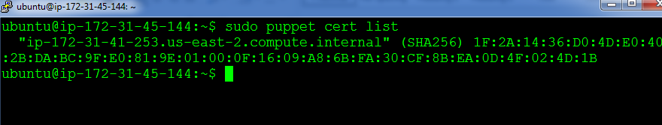

**Step 2:** Finally, sign the listed certificate using the following command:

$ sudo puppet cert sign --all

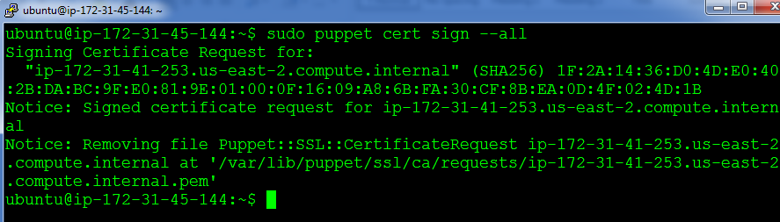

You are now ready to use the Puppet cluster!